# KENDRIYA VIDYALAYA No.2, BOLANGIR

SUMMATIVE ASSESSMENT- II SESSION: 2013-14

CLASS: III SEC___ TIME: 2 ½ Hrs

SUBJECT: ENGLISH MAX.M: 60

NAME: ________________________________________________ Roll No.:______ DATE: ____-03-2014

Invigilator’s Sign______ Examiner’s Sign. _________

|  |  |  |  |  |  |  |  |
| --- | --- | --- | --- | --- | --- | --- | --- |
| COMPETENCIES | READING | TEXT | GRAMMAR | CREATIVE WRITING | SPELLING | HANDWRITING | OVER ALL |
| GRADE |  |  |  |  |  |  |  |

READING

Q1. Read the passage and answer the following question:-

Once upon a time there was a small hill. A path went up the hill. It went through thick and lovely woods of pine and fir trees. People often walked on it to a holy place. One day when the sum shore high in the sky many people were seen climbing up the hill. They were climbing slowly and carefully. A girl also climbed the hill with them. Her name was Meena. Meena was twelve years old. She carried a small boy on her back. He was four years old. His hair was curly. His eyes were black and his face was as fresh as the morning dew. As the sunshine danced through the trees. Meena climbed the hill slowly and carefully. Meena was happy. The boy was also happy.

1. Where were the people going?

________________________________________________________________

1. What went up the hill?

________________________________________________________________

1. How were the people climbing?

________________________________________________________________

1. What was the name of the girl?

________________________________________________________________

1. How old was the girl?

________________________________________________________________

1. How old was the boy?

________________________________________________________________

Do as directed

1. Write the opposite of the following

Quickly _____________

Sad _____________

1. Write the present tense

Carried ______________

Climbed ______________

1. Write the singular form

Girls ______________

Boys ______________

1. Write the comparative form

Thick ___________ Thickest

READING (UNSEEN PASSAGE)

Q2. Read the passage and answer the following question:-

Early rising is a healthy habit. It keeps us fit and fine. The morning air is cool and fresh morning exercise is very useful for our lungs. It keeps our body strong and healthy throughout the day. It is very calm at that time. There is no noise or sound. A student can read peacefully. He can learn his lessons easily and recall it well. So every student should get up early.

1. What is useful for our lungs?

________________________________________________________________

1. Should a student get up early?

________________________________________________________________

1. Why is early rising a healthy habit?

________________________________________________________________

1. What is cool and fresh?

________________________________________________________________

1. When can a student learn his lessons easily?

________________________________________________________________

________________________________________________________________

Do as directed –

* 1. Write the opposite of the following
     1. Weak ___________ Evening _________
  2. Fill the blanks with proper word from the bracket
     1. Water is _____ (peacefully / useful) for our body.
     2. There is a lot of ______ (noise / calm) in the market.
  3. Write the past tense of ‘learn’ ___________.
  4. Pick out the silent letter .

Calm: ________

TEXTUAL UNDERSTANDING

Q3. Answer the following questions given below:-

1. How old was the speaker of the poem, “Don’t Tell”?

Ans:-____________________________________________________

________________________________________________________

1. What did the man say to Meena?

Ans:-____________________________________________________

________________________________________________________

1. Why is the camel called the ship of the desert?

Ans:-____________________________________________________

_________________________________________________________

1. What does the camel eat in the desert?

Ans:_____________________________________________________

_________________________________________________________

1. Write the action words from the following stanza-

But boys and girls

Have much more fun

They leap and dance

And walk and run

Ans:_________________________________________________________ CREATIVE WRITING

Q4. Look at the picture of the beach and write 5 sentences about it :-

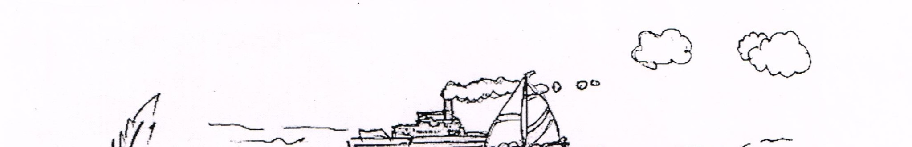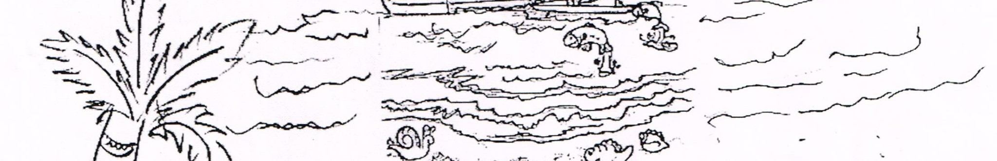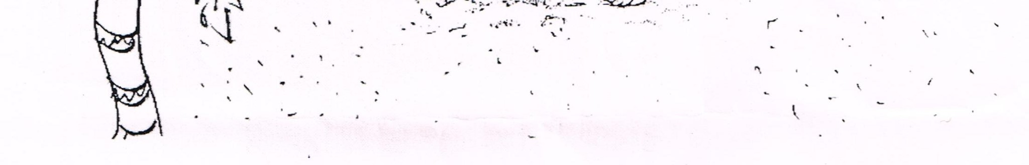

________________________________________________________________________

________________________________________________________________________

________________________________________________________________________

________________________________________________________________________ ________________________________________________________________________ ________________________________________________________________________

________________________________________________________________________

GRAMMAR

1. Make 2 words from the following word FROWNING ______ ______
2. Arrange these movement words from slow to fast (run,walk, hot, crawl)

_____ _____ _____ _____

1. Underline the letters which are silent in the following words

Walk Straight

1. Fill in the blanks with the opposite of the underlined word given in the sentence – (i) The rat ran in when the cat ran_______.

(ii) Trees are tall but the bushes are ______.

1. Fill in blanks-

One child many_________.

1. Add ‘ly’ to make a word

Let us sing ________(soft)

1. Add ‘ful’ to make a word

The books are______ (use)

1. Make sentences with each word

Here : ________________________

Hear :_________________________

1. Make meaningful word by adding ‘e’ at the appropriate places.

Agl________ prfet___________

1. Fill the vowels and make correct words

T____ ____ ch____ r C___ rpnt ____ r

## SPELLING

|  |  |
| --- | --- |
| Q5. | Encircle the correct one –   1. Whiskers Wikers Wheekers 2. Cretures Creature Crreturs 3. Enugh Enuogh Enough |
| Q6. | Fill the blanks   1. A ____ mends our shoes. 2. An _____ travel in a spacecraft.   HANDWRITING |
| Q7. | Rewrite the following in neat and clean handwriting:- |
|  | Light given of itself freely, filling all available space. It does not seek anything in |

return. It asks not whether you are friend or foe.

________________________________________________________________________

________________________________________________________________________

________________________________________________________________________ ________________________________________________________________________

________________________________________________________________________ ________________________________________________________________________

________________________________________________________________________

________________________________________________________________________

# KENDRIYA VIDYALAYA No.2, BOLANGIR

SUMMATIVE ASSESSMENT- II SESSION: 2013-14

CLASS: IV SEC___ TIME: 2 ½ Hrs

SUBJECT: ENGLISH MAX.M: 60

NAME: ________________________________________________ Roll No.:______ DATE: ____-03-2014

Invigilator’s Sign______ Examiner’s Sign. _________

|  |  |  |  |  |  |  |  |
| --- | --- | --- | --- | --- | --- | --- | --- |
| COMPETENCIES | READING | TEXT | GRAMMAR | CREATIVE WRITING | SPELLING | HANDWRITING | OVER ALL |
| GRADE |  |  |  |  |  |  |  |

READING

Q1. Read the passage carefully and answer the questions given below.

*Once Upon a time, an old Carpenter bought a very queer piece of wood. As he*  *used his plane on it, he heard a little laughing voice say, “Stop you are tickling me”.*

*The old man was puzzled by the voice.*

*He said,” This is a strange piece of wood. What shall I do with it? I think. I shall*

1. What did the carpenter buy?

___________________________________________________________________

___________________________________________________________________

1. What did he make out of it?

___________________________________________________________________

___________________________________________________________________

1. What did the carpenter hear, while using plane on wood ?

___________________________________________________________________

___________________________________________________________________

1. Was the Piece of wood strange?

___________________________________________________________________

___________________________________________________________________

1. Write the past tense of “PUZZLE”.

___________________________________________________________________

1. Write the opposite of “START”.

___________________________________________________________________

1. Find out the word from the passage which means” UNKNOWN”.

___________________________________________________________________

1. Write a rhyming word for” Jingling”.

___________________________________________________________________

1. Find out a describing word from the passage.

___________________________________________________________________

1. Write an interrogative sentence from the given passage?

___________________________________________________________________

___________________________________________________________________

Q2. Read the passage carefully and answer the questions given below.

*An officer army in the American army was getting some logs of food shifted from one*  *place to another. They were so heavy that his soldiers could not lift them. He did not help his men and shouted at them for delaying the work.*

*Just then a gentleman who was passing by stopped and asked the officer why he was not*

*helping them.”Do you know who I am?”Said officer, “I am an officer, how can I do such*  *small work?”*

*“I see”, the man replied. He rolled up his sleeves and began to help the soldier. In no time the logs were shifted. While going away the gent*(7) *leman asked the officer to send for*  *him whenever his men needed any help.’’Who are you?”Asked the officer. The gentleman*

a) What did the carpenter buy?

Choose the correct answer.

1. The story takes place in
   1. Europe b. America c. India d. China
2. The men couldn’t lift the logs because
   1. They were lazy b. The officer was shouting at them

c. The logs were heavy d. They did not want to work

1. The officer did not help them because
   1. He had no time for such work b. He was too important to do such work

c. He was not feeling well d. The work was very easy

1. George Washington helped the men because
   1. The solider asked him for help
   2. He had no other work
   3. The officer was not feeling very well
   4. He thought that everyone should do all types of works
2. Find words from the passage which are opposite to :

a) Light X _____________ b) Big X _____________

1. Pick out the word from the passage which has the same meaning as :

Piece of wood cut from the tree:-____________

Q3. Answer the following questions briefly:

1. Why was the officer shouting at them?

___________________________________________________________________

___________________________________________________________________

1. What work were the soldiers of American army doing?

___________________________________________________________________

___________________________________________________________________

1. Why was the work getting delayed?

___________________________________________________________________

___________________________________________________________________

1. What lesson did George Washington teach the officer?

___________________________________________________________________

___________________________________________________________________

TEXTUAL UNDERSTANDING

Q4. Answer the following questions:

1. What did Pinocchio say in the end?

___________________________________________________________________

___________________________________________________________________

1. How did the learned pundit challenge everybody?

___________________________________________________________________ ___________________________________________________________________

1. Which part of the plant should be watered ?

___________________________________________________________________

___________________________________________________________________ d) Complete the stanza:

There was a _____________ boy, And a naughty boy was he.

He _____________ away to _____________,

The people there to _____________

Q5. Read the following lines of poem and answer the following questions.

‘’Then the little Hiawatha

Learned of every bird its language.”

a) Name the poem from which these lines have been taken.

_________________________________________________________________ b) Name the poet of the poem.

_________________________________________________________________

GRAMMAR

Q6. Do as directed :

1. Write the rhyming words:

Found: ______________ Weighty: ________________

1. The monkey has a long __________ (tail/tale).
2. I have to leave at ________________ ( too/ two) . ( choose the correct word )
3. Give another word that means :

Completed ________________

1. The soldiers fought ________________ (brave)

(Use the adverb form of the given word)

1. The plant has many _____________(flower/flowers).
2. Do you like mango juice _________(and/or) orange juice?
3. I am proud to be an _______________(India)

(Use the correct form of the given word)

1. Write the opposite of ‘efficient’: ________________
2. Make the noun form of ‘public’: _______________ SPELLING

Q7. Fill in the blanks to make meaningful words:

a) pu__z___e (b) ama__ e___ (c) me__ ___y

(d) g__lo__e (e) deli__i___us

CREATIVE WRITING

Q8. Write five lines on ‘My school library ’ or ‘My favourite teacher ’

________________________________________________________________________

________________________________________________________________________

________________________________________________________________________ ________________________________________________________________________ ________________________________________________________________________ ________________________________________________________________________

________________________________________________________________________ ________________________________________________________________________

Q9. Look at the following picture and write five lines:

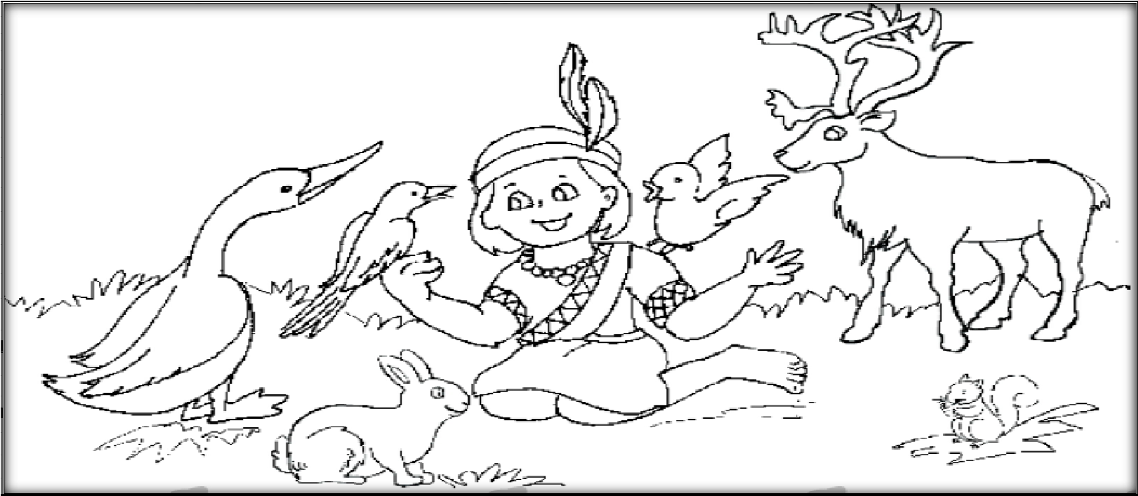

________________________________________________________________________

________________________________________________________________________ ________________________________________________________________________ ________________________________________________________________________

________________________________________________________________________

________________________________________________________________________

HANDWRITING

Q10. Write the following passage neatly.

All the great teachers, saints and successful person of the world are unanimous in having full faith in the saying that our deeds determine our destiny. By their own practical experience, they had all realized the great truth of the above statement. If we study the life and struggles of the great men and women who have left their foot prints on the sand of time, We shall find that these great souls were not extraordinary beings. They too were also men and women in flesh and blood like us.

________________________________________________________________________

________________________________________________________________________

________________________________________________________________________ ________________________________________________________________________ ________________________________________________________________________

________________________________________________________________________

________________________________________________________________________ ________________________________________________________________________ ________________________________________________________________________

________________________________________________________________________ ________________________________________________________________________

________________________________________________________________________

# KENDRIYA VIDYALAYA No.2, BOLANGIR

SUMMATIVE ASSESSMENT- II SESSION: 2013-14

CLASS: V SEC___ TIME: 2 ½ Hrs SUBJECT: ENGLISH MAX.M: 60

NAME: ________________________________________________ Roll No.:______

DATE: ____-03-2014

Invigilator’s Sign______ Examiner’s Sign. _________

|  |  |  |  |  |  |  |  |
| --- | --- | --- | --- | --- | --- | --- | --- |
| COMPETENCIES | READING | TEXT | GRAMMAR | CREATIVE WRITING | SPELLING | HANDWRITING | OVER ALL |
| GRADE |  |  |  |  |  |  |  |

READING

Q1 Read the following passage and answers the questions given below.

Once upon a time, not so very long ago, there was a small boy called Hari. Although he wasn’t very big, he was strong, and he loved to tease all the boys and girls who went to school with him. What he loved to do most was to pinch. He could make a big bruise appear in half a second. Another trick he played was pricking people with a pen.

So you can guess how all the children hated him. They tried pinching him back, but that was no good because he could always pinch harder. They didn’t like telling their teacher, because that was telling tales.

1. What was the name of the boy?

Ans: ______________________________________________________________

1. What was special about him?

Ans: ______________________________________________________________

1. What did he like to do?

Ans: ______________________________________________________________

1. Did the children like him?

Ans: ______________________________________________________________

1. Use the word – ‘tease’ in your own sentence.

Ans: ______________________________________________________________

1. Choose any two naming word (nouns) from the passage.

Ans: a)_________________________ b) _________________________________ g) Write any two describing words (adjectives)

Ans: ______________________________________________________________

1. Write the opposites of the following.
2. Weak X_________________ ii) Short

X_______________________

1. Write the past tense of the following.

i) love _______________ ii) play ____________________

Q2 Read the following passage and answer the questions given below.

There was a miller who liked to talk about himself all the time. One day, he met the King. The miller said, “Your Majesty, I have a daughter who can spin straw into gold.” So the king, who liked gold, put the miller’s daughter into a room filled with straw and a spinning wheel, and said, “If you can spin this straw into gold by morning, you will be my queen. If not, you will die!

The girl, who wanted to like, began to cry. Suddenly, a little man appeared, and said, “If I spin your straw into gold, will you give me your first born child?”

1. What did the miller like to do?

Ans: ___________________________________________________________

1. Whom did he meet?

Ans: ___________________________________________________________

1. Whom does the word ‘your majesty’ refer to?

Ans: ___________________________________________________________

1. What was special about the miller’s daughter?

Ans: ___________________________________________________________

1. What was there in the room?

Ans: ___________________________________________________________

1. Spinning = ________+ ing

1. Find the opposite gender of the following.

i) Son _____________________ ii) King________________________

1. Write any two action words (verbs) from the passage.

Ans: i) __________________________ ii) _________________________ i) Give the past tense of

1. Begin_________________ ii) Meet _____________________
2. Give a suitable title to the story.

Ans: __________________________________________________________ WRITING

Q3. Why did the train stop for the first time?

Ans: __________________________________________________________________

__________________________________________________________________

Q4. Why did the monsters put Gulliver on the ground to look at him ?

Ans: __________________________________________________________________

__________________________________________________________________

Q5. Complete the lines of the poem from your textbook.

She had no choice , ________________________________________,

____________________________________________swim that day ,

Tight she gripped her ______________________________________, Into the ___________________________________________to land.

Q6. Why did the people of Kangleipak love their king and queen?

Ans: __________________________________________________________________

__________________________________________________________________

__________________________________________________________________

Q7. Why was the girl quiet in the poem “Class discussion”?

Ans: __________________________________________________________________

__________________________________________________________________

GRAMMAR

Q8. Write the full form of

1. We’ll ____________________
2. We’re ___________________________

Q9. Fill in the blanks with suitable prepositions:

1. The tree was the home ____________ a flock of _____ wild geese.
2. The frogs jumped ___________ the well.

Q10. Rearrange the words to from a sentence.

The / I / went / footprint / large / towards. ________________________________________________________________

Q11. Fill in the blanks using ‘for’ (or) ‘since’

1. I have lived in this house ___________I was a baby.
2. This big jar has been in our family_______ many years.

Q12. Write the opposites of the following using (un, im, dis)

1. Obedient ________________
2. Important ___________________

Q13. Write the present form of the following verbs.

1. Wanted_________________
2. Said____________________

Q14. Fill in the blanks with appropriate article (a an, the)

1. I found ____________ empty bottle, floating in the water.
2. The boys and girls went to _____________ seaside for a picnic.

Q15. Use the adverb form of the given word.

The girls are singing ________________(loud)

Q16. Fill the blanks given below with question words (where,what)

1. _____________ do you want for your birthday?
2. _____________ do you play?

Q17. Add ‘er’ (or) ‘est’ to the describing words and fill in the blanks:

1. The car is ______________ than the sail boat (fast)
2. Which is the ______________ of two parcels ? (good)

CREATIVE WRITING

Q18. Write at least five sentences about any one of your teachers.

________________________________________________________________________ ________________________________________________________________________

________________________________________________________________________ ________________________________________________________________________ ________________________________________________________________________ ________________________________________________________________________

________________________________________________________________________ ________________________________________________________________________ ________________________________________________________________________

________________________________________________________________________

________________________________________________________________________

________________________________________________________________________

Q19. Write five things that you do at home to make your home look neat and clean.

________________________________________________________________________ ________________________________________________________________________ ________________________________________________________________________

________________________________________________________________________ ________________________________________________________________________ ________________________________________________________________________ ________________________________________________________________________ ________________________________________________________________________ ________________________________________________________________________ ________________________________________________________________________

________________________________________________________________________

________________________________________________________________________

SPELLING

Q20. a) Fill in the blanks to make meaningful words.

i) T___I UMPHAN__LY ii) CA __YO___

iii) GR___ MP___

b) Encircle the correct spelling.

|  |  |  |
| --- | --- | --- |
| i. | Please | Pleaze |
| ii. | Patient | Pecent |
| iv. | Content | Contant |

v. Whistle Wistle

HANDWRITNG

Q21. Write the following passage neatly.

The kangaroo is an animal found in Australia. These animals were given their name by the famous English captain, James Cook, who discovered Australia. Pointing to one of the animals, he asked an Australian what it was called. “Kangaroo” replied the man, which, in his language, meant, “I don’t know.” Kangaroos have very large hind legs upon which they stand. They also use these hind legs to jump from place to place.

________________________________________________________________________

________________________________________________________________________ ________________________________________________________________________ ________________________________________________________________________ ________________________________________________________________________

________________________________________________________________________

________________________________________________________________________ ________________________________________________________________________ ________________________________________________________________________

________________________________________________________________________